* <https://docs.microsoft.com/en-us/azure/storage/common/storage-sas-overview>
* 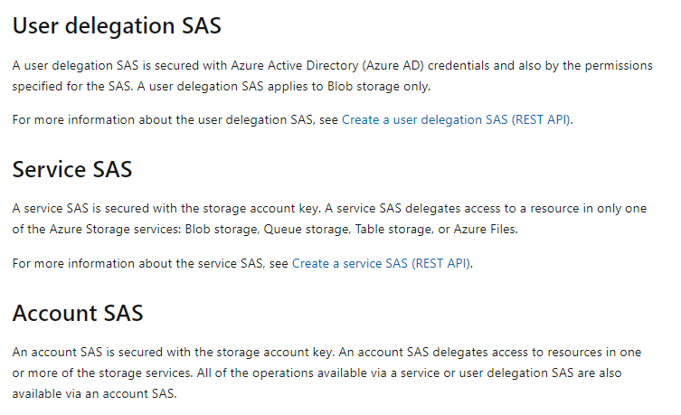
* Giving people access to the shared resources SAS is used.
* Access key will give full access to the storage accounts.
* Microsoft give 2 keys to avoid the downtime
* 